Battle of Neighborhoods

Long Island City (Queens), NY and Harbourfront East (Toronto), ON comparison

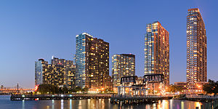Long Island City, NY

Harbourfront East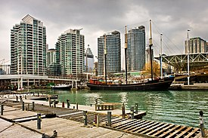

Problem and discussion:

In September of 2017, Amazon announced via a request for proposal (RFP) that it was seeking a second North American headquarters in which it could potentially hire up to 50,000 employees. Over 200 cities and municipalities responded to Amazon’s RFP with a multitude of options and tax incentives.

In January of 2018 the list of 200+ was reduced to 20 finalists. Among those finalists were New York and Toronto. In November 2018 Amazon made its decision by splitting it’s second headquarters in two, one part in New York, the other in Northern Virginia.

Although Toronto lost, they did make it to the finalist list and are still a very desirable location and competitor for other large technology corporations seeking to expand their operations not only to the East Coast, but also to one of Canada’s technology hubs.

Assuming the role of a real estate developer, or that of a restaurateur, it may be interesting to know what kinds of venues are located in the areas that both New York and Toronto chose as potential sites for Amazon’s HQ2. Any location that could potentially host up to 50,000 people would definitely provide opportunities for opening or expanding small businesses like eateries, restaurants, bars, and more. In the case of New York, the neighborhood of Long Island City was chosen. As for Toronto, Harbourfront East was one of their primary choices.

There are many factors that must have gone into Amazon’s decision as to what site to choose for HQ2. This project will only look at these neighborhoods from the perspective of what types of venues are located within these neighborhoods and rank how common certain venues are. We’ll then compare those of Long Island City and Harbourfront to see any similarities or differences. The resulting data may or may not help to inform future business planning or investment in Harbourfront based on what worked for Long Island City.